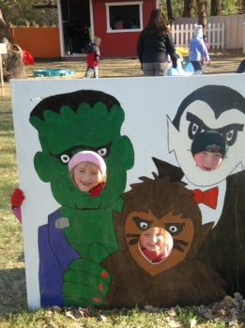

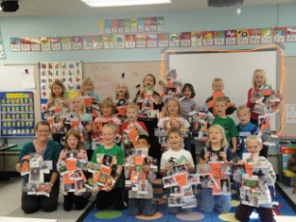Wow! I’m pretty sure that is the only word I can use to explain our entire (short) week! It was crazy busy and a ton of fun!

**Spelling List**

C:\Users\taolson\AppData\Local\Microsoft\Windows\Temporary Internet Files\Content.IE5\CT93IAZ4\MC900048276[1].wmfAgain this week the spelling list is on the back of todays newsletter. We will be testing on these words on Wednesday and again on Friday. I will take the best of the two scores for the final grade. We are starting with just six words but the list will gradually grow as we get into our reading curriculum.

There is a great website available to help your student work with our spelling words each week. The site is: [www.spellingcity.com](http://www.spellingcity.com) I have now entered the lists under my name. If you go to the sight then click on find a list and type in Tori Olson all of our lists will show up. There are many great word games that you can play on this sight. A favorite so far in our room is “Hang Mouse” with color words. Hit the web and give it a try!

**Conferences**

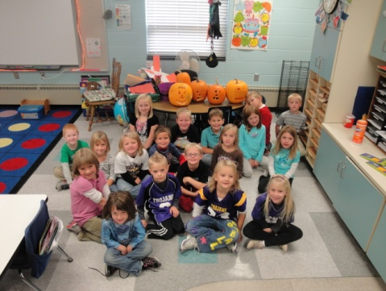**Conferences are in the process of being planned. There has been a schedule change- those who selected Tuesday Nov 8th as their preferred day will be changed to Monday Nov 7th (Tuesday is Election Day so we are unable to conduct conferences that night). If this is a problem with your schedule please let me know as soon as possible and we can work something out. The final conference schedule will be mailed home soon.**

Timelines

I would like to thank all the volunteers who came to help with this fabulous project. The kids had a great time and we love sharing the pictures and stories! If you have any snapshots from that day please send them my way!

Buffalo River Pumpkin Patch

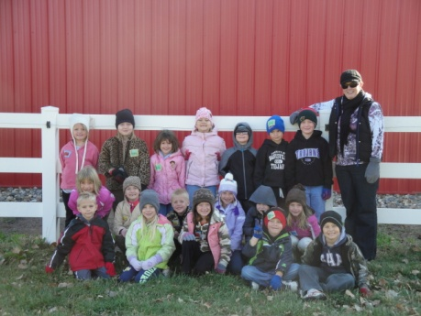A little wind wasn’t going to keep us away! The pumpkin patch was a great experience. We got to enjoy a hay ride, straw maze, games, petting zoo and lots of exploring! The picnic was a little tricky with the wind but we made it! Hope all the pumpkins made it home safely!

Pumpkin Math

Great and messy fun! Thanks to the volunteers who came in today to help with this pumpkin activity. We had a great time and have some wonderful pumpkin faces lighting up our room!